REPORT ON INPLANT TRAINING
Undergone at
NXTGEN INSTRUMENTS
Erode

Submitted by

NAME: SABARI SRI P
ROLL NO: 24ADR131

DEPARTMENT OF ARTIFICIAL INTELLIGENCE AND
DATA SCIENCE


KONGU ENGINEERING COLLEGE
(Autonomous)
PERUNDURAI, ERODE – 638060

DECEMBER/2025

Industry Preamble

Name of the Industry | NXTGEN INSTRUMENTS
Nature of Industry  Scale: Large/ Medium | Medium
Nature of the business:  (Software/Manufacturing/Automobile/  Export/Textile....etc | Software/web designing/placements
Name of the Reporting Authority with  Designation, Contact number and Mail ID | Name: Gopinath P  Email: nxtgeninstrumentsind@gmail.com  Contact number: 8883363799

Description about the Industry

NextGen Solutions is a leading technology company specializing in advanced IT services, software development, and data-driven solutions. The company focuses on emerging technologies such as Artificial Intelligence (AI), Machine Learning (ML), Internet of Things (IoT), and Cloud Computing to provide smart business solutions for various industries. With a strong emphasis on innovation and automation, NextGen empowers clients to transform their digital strategies and enhance operational efficiency. Their R&D-driven approach and real-time project exposure offer students an excellent opportunity to gain hands-on experience in the field of Machine Learning

Process Flow Diagram

Client Requirement Analysis → Cloud Planning & Feasibility → Architecture & UI/UX Design → Web Development (Frontend & Backend) → Testing & Validation → Cloud Deployment → Training & Documentation → Support & Maintenance

Description of Work Assigned

SOFTWARE BRANCHES
Requirement Analysis:
Conduct meetings with students/clients to capture objectives, spec outcomes, deadlines.

Document functional requirements like IEEE-compliance, tech stacks (.NET, Java, AngularJS)
Click.in Define interfaces, expected deliverables, and non-functional needs.
System Design:

Architect data flow diagrams (DFDs), ER diagrams, and modular blueprint.

Use design tools (e.g., UML), wireframes for web/mobile apps.

Base architecture on best practices and referenced from training materials.
Coding and Implementation:
Develop modules using chosen cloud technologies: AWS, Azure, GCP, Node.js, Python, Docker.

Follow modular, reusable, and version-controlled cloud-native coding approaches.
Testing and Debugging
Conduct unit tests, integrate modules, and perform integration/UAT testing.

Report bugs using bug-tracking tools.

Debug to ensure compliance with functional behavior and client requirements.

Deployment and Documentation
D eploy to a test server or staging environment before final release.

Compile technical documentation: architecture diagrams, user guides, installation steps.

Maintain project repositories and archival of code, reports, and presentations.

Quality Inspection & Tools Used
At each phase:

Design Review: Ensure architecture meets requirement specs.

Code Review/Testing: Unit, integration, user acceptance.

Post-deployment QA: Verify environment and performance.

Tools: Turnitin for plagiarism, Git, testing frameworks, possibly CI/CD scripts.
Geo Tag Photo:

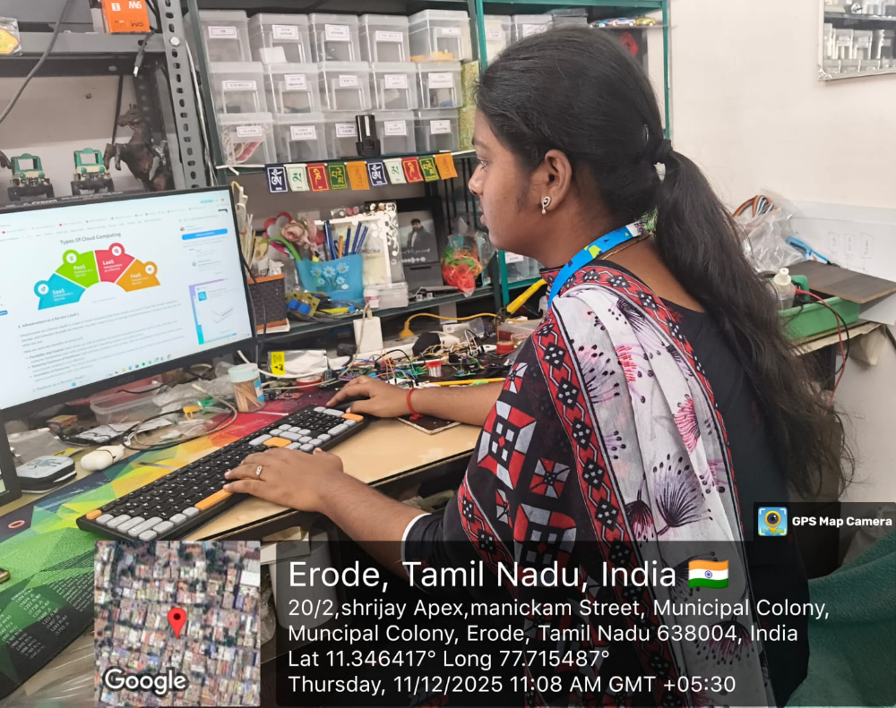

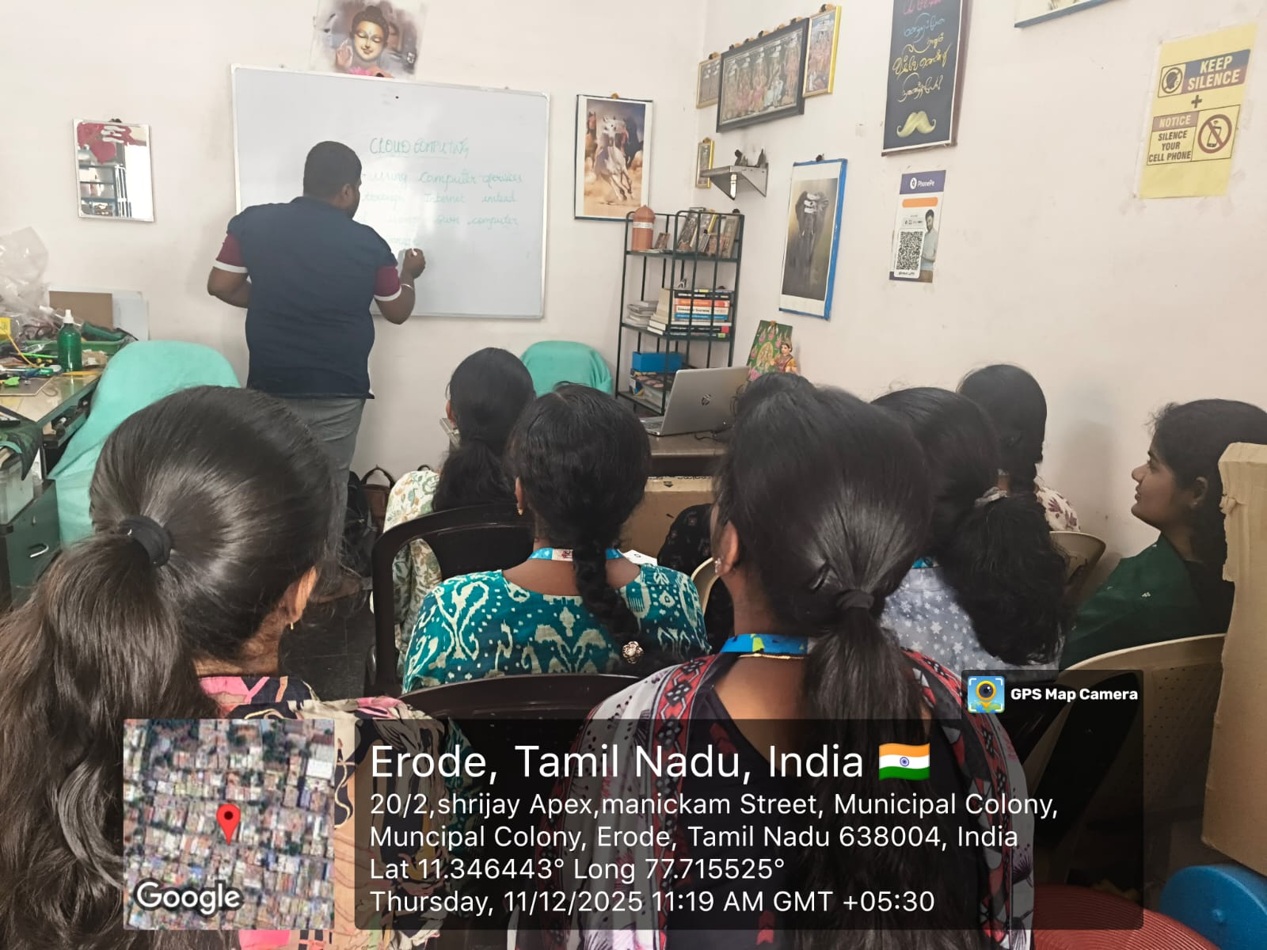

Remarks from the Reporting Authority

(1 — Good 2— Average 3 — Needs Improvement)
Time Management Rating: 1 2 3
Learning Attitude Rating: 1 2 3
Technical Skills Rating: 1 2 3

Specific Comments (If any):
Student
(Signature)
Academic Mentor Industrial Mentor
(Name, Official Seal, and Signature) (Name, Official Seal, and Signature)
Head of the Department
(Name, Official Seal, and Signature)

